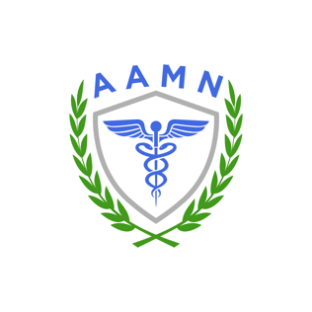

HOW TO USE THIS YEAR’S ELECTRONIC APPLICATION FORM

Once again this year, AAMN is utilizing an electronic application for organizations applying for our Best Schools for Men in Nursing and Best Workplaces for Men in Nursing awards.

If you are not familiar with this form, we wanted to provide you with some answers to common questions about how to properly complete the application.

Why the need for an electronic form?

The form is designed to expedite the reviews of the applications, which are submitted in a variety of methods — from PowerPoint presentations to video portfolios to PDFs and more. There’s never been a wrong way to submit, but for our team of reviewers, making sure each applicant submits the data we’re looking for sometimes can be easier to find on some applications than others. So we’re trying to reduce the time spent searching for answers and create more time for reviewing the answers.

What format is best for submitting the application?

Again, there’s no wrong format to use. If you’ve always produced a PowerPoint presentation, for instance, you can do that again. But we’re just asking for a little extra help in finding the relevant data.

How do I use the electronic application form?

Once you’ve filled in your name, your organization’s name, contact information, etc., hit the NEXT PAGE button.

Once on Page 2, you’ll find some tips for how to use the form. Near the top of Page 2, there is a box where you can attach a PowerPoint, PDF, or any other file that contains your full application if you chose to create one.

Below that box, you’ll find questions/requests for information that we analyze when reviewing your application. Each question has two boxes that can be used for providing an answer: A text box, and a box where relevant files or documents can be attached.

Do I need to provide a text response and attach files for each question?

No, it can be one, or the other. But you’re also free to do both. If your answer to a question is contained in a larger presentation you’ve already attached, please guide our reviewer by writing a brief description of where they can find that information. For instance, if you submitted a PowerPoint, you could write something like, “The requested information is found on Slide 9.” If your answer to a question can’t be answered in simple text form, you can simply attach an electronic file in virtually any format as a way to provide the data requested. But if you need to provide background information regarding something you’ve attached electronically, feel free to do so by adding written text along with the attached file.

What if I don’t have an answer for every question?

If no answer is available, simply write “not available” or something similar in the text box provided for that question. Don’t leave both the text box and the box for file attachments blank, as we won’t know if we’re still waiting for that information to be provided.

I’ve started working on the application, but realized I’m missing data. Can I save what I have and submit later?

Once you begin work on an application, the submission form won’t save your work if you close out of the form. So get as much information gathered as possible before starting to complete the application.

However, if you have some of the form complete, you may submit a partially completed form — provided that you open a second form and fill in the missing information and submit. If submitting a second form, you do not need to fill in all of the information previously submitted (unless it required updating). EXAMPLE: Let’s say you were able to answer all but one question, but the information you need for the remaining question won’t be available until the next day. You may submit the partial form today, then tomorrow you can open a new form, answer just the missing question, and submit. We’ll take the two submitted applications and merge them into one on our end.

Remember, if you must submit a second application to answer any remaining questions, BOTH forms must be submitted by the deadline of 11:59 pm Eastern time on June 14, 2024.

